CSA 1717-ARTIFICIAL INTELLIGENCE
LAB EXPERIMENTS
Abinaya Sri J(192524429)
AIM
To solve the Water Jug Problem using the Breadth-First Search (BFS) algorithm in Python to obtain the required amount of water.
OBJECTIVE
To find the sequence of operations required to measure the desired quantity of water using two jugs. To understand the concept of State Space Search and Breadth-First Search (BFS) in Artificial Intelligence.
ALGORITHM
Step 1: Start the program.
Step 2: Define the capacity of the two jugs.
- Jug A = 4 liters
- Jug B = 3 liters
Step 3: Set the initial state as (0, 0), where both jugs are empty.
Step 4: Create an empty queue to store the states for Breadth-First Search (BFS).
Step 5: Create an empty visited set to avoid processing the same state more than once.
Step 6: Insert the initial state (0, 0) into the queue.
Step 7: Remove the first state from the queue.
Step 8: Check whether either jug contains 2 liters.
- If Yes, print the solution path and stop the program.
- If No, continue to the next step.
Step 9: Generate all possible next states using the following operations:
- Fill Jug A.
- Fill Jug B.
- Empty Jug A.
- Empty Jug B.
- Pour water from Jug A to Jug B.
- Pour water from Jug B to Jug A.
Step 10: Check whether each newly generated state has already been visited.
- If it has not been visited, add it to the queue and mark it as visited.
Step 11: Repeat Steps 7 to 10 until the goal state is reached.
Step 12: Display the sequence of states that leads to the goal.
Step 13: Stop the program.
SOURCE CODE
from collections import deque
def water_jug():
visited = set()
queue = deque()
# Initial state (Jug A = 0L, Jug B = 0L)
start = (0, 0)
queue.append((start, [start]))
while queue:
# Remove the first state from the queue
(a, b), path = queue.popleft()

# Skip if already visited
if (a, b) in visited:
continue
visited.add((a, b))
# Goal condition
if a == 2 or b == 2:
print("Solution Path:")
for state in path:
print(state)
return
# Generate all possible next states
next_states = [
(4, b), # Fill Jug A (4L)
(a, 3), # Fill Jug B (3L)
(0, b), # Empty Jug A
(a, 0), # Empty Jug B
# Pour Jug A to Jug B
(a - min(a, 3 - b),
b + min(a, 3 - b)),
# Pour Jug B to Jug A
(a + min(b, 4 - a),
b - min(b, 4 - a))
]

# Add new states to the queue
for state in next_states:
if state not in visited:
queue.append((state, path + [state]))
# Call the function
water_jug()
FLOW CHART
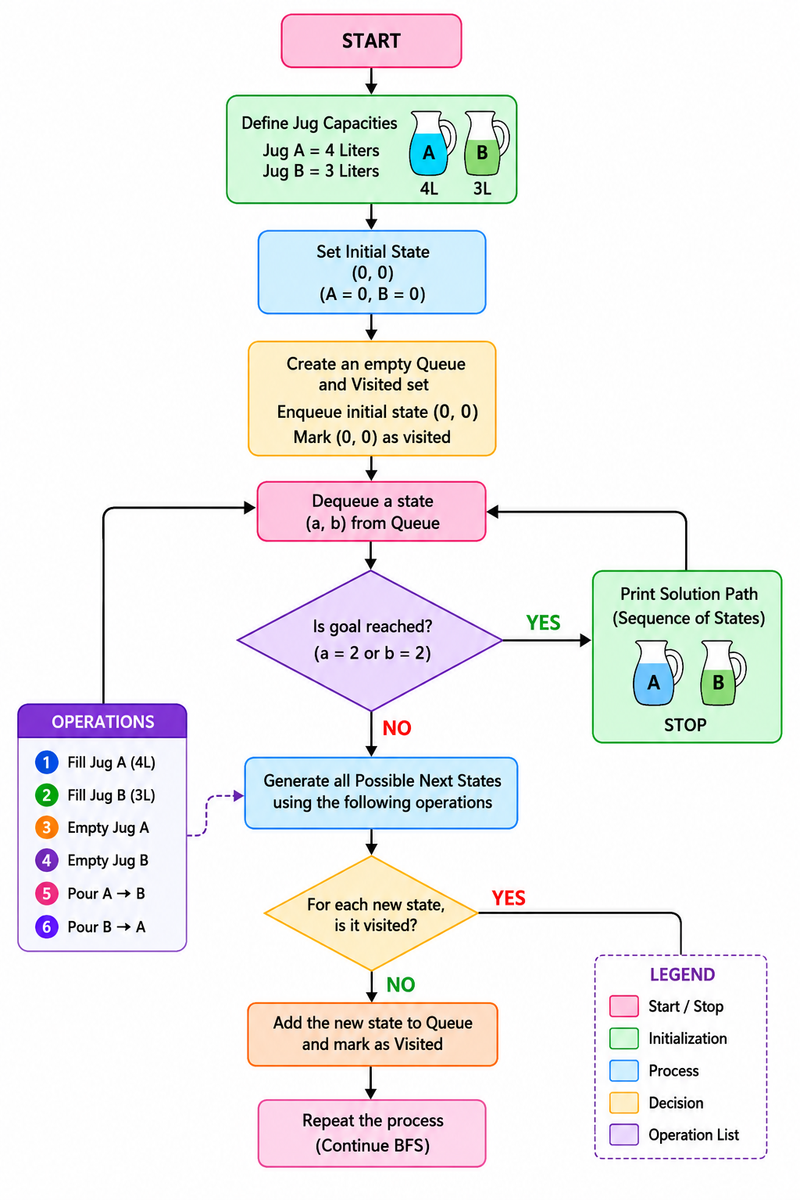

OUTPUT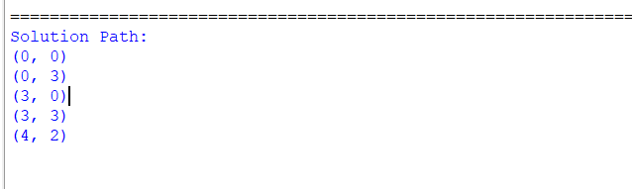
RESULT
The Water Jug Problem was successfully implemented in Python using the Breadth-First Search (BFS) algorithm, and the required 2 liters of water was obtained successfully.

